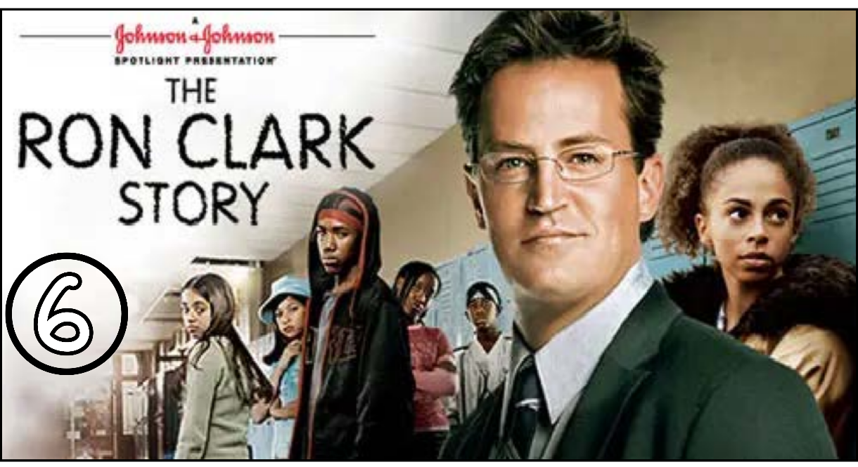
“The Ron Clark Story” (Scene 06)

Part 01 / Work on the Scene

- Scene summary: (each student must participate / ONE BY ONE)

“The scene begins with Julio in the principal’s office, telling him that they are without a teacher and that under these conditions they have to go home. But the principal tells him that he will find a way to bring Mr. Clark back. When they return to the class, they are surprised to find Mr. Clark already there. The class begins with a deal between Mr. Clark and the students, which makes the learning process very fun and enjoyable for everyone. Later, in the courtyard, Mr. Clark makes another deal with the students: if he succeeds in learning double dutch, they will learn the entire 7th grade program from him.”

- Scene Discussion & Analysis: (All the group participate at once)

- Q01: Did Mr. Clark come back?
Yes, he did.
- Q02: How did Mr. Clark get his students to follow with him?
He made a deal with them that if they were quiet and they listen every 15 seconds he will drink a chocolate milk. So they may see him puke.
- Q03: Did he actually puke eventually?
No, he didn’t
- Q04: In your opinion, what does that demonstrate?
He finds a way to teach them and keep them quiet
- Q05: What was the second deal he made with his students before they agreed to learn everything they need for 7th grade?
In the courtyard, Mr. Clark makes another deal with the students: if he succeeds in learning double dutch, they will learn the entire 7th grade program from him.
- Q06: Did he succeed, eventually? Did Mr. Turner accept his acting? And why?
Yes, he did. Mr. Turner didn’t accept his behavior, because according to him, a teacher shouldn’t play with their students.

Part 02 / Acquired vocabulary & Grammar from the scene

- Acquired Vocabulary (OPTIONAL):

- Crazy mad:
- Example in a sentence:
“ He must be completely crazy to drive that fast in the rain. .”
- Gone for good / To go for good
- Example in a sentence:
“ After he moved abroad, he was gone for good. .”
- To puke
- Example in a sentence:
“My children don’t like to travel long distances because they might puke. .”

- Irregular Verbs:

Infinitive | Past simple | Past participle
To eat | ate | eaten
To hear | heard | heard
To feel | felt | felt
To come | came | come
To go | went | gone

- Grammar note from the SCENE: (All the group participate at once)

Mr. Turner says in [00:10]: “If Mr. Clark is not in his class, I am sure we can find someone to cover for him.”
Mr. Clark says in [01:20]: “If you sit quite, I will drink a chocolate milk every 15 seconds.”

- What do those two sentences express?
- The two sentences express “condition”.
- Do they represent the same Type?
- No, they don’t.
- What Type does each sentence represent?
- Sentence 01 represent type 00.
- Sentence 02 represent type 01.
- When do we use Type 00 and when do we use Type 01?
- Type 00 is used to express / to indicate certainty.
- Type 01 is used where the conditional case doesn’t live up to “certainty”.

Part 03 / TRANSCRIPTION: improve your listening (Optional)

Task: Transcribe sentences from the scene.
- Transcribe Sentence 01
- what … but Mr. Clark isn’t in the class so I am sure we can find someone to recover him.

- Transcribe Sentence 02
- Within this four walls you can be strangers or you can be a family. Within this four walls it can be the end of your story or you can make it a beginning
- Transcribe Sentence 03
- You really think it is proper to do this with the students.

Open discussion (OQ)

- Topic of discussion: We see that Mr. Clark wanted to win his students’ trust so badly that he even tried to play with them during recess time which made him look like a fool. Mr. Turner thinks this was inappropriate. Do you agree with Mr. Turner? Why? Or why not? Also, can you suggest some alternative ways that Mr. Clark could have tried instead of embarrassing himself in front of everyone in school??
(Students are free to participate and interact to share their own opinions.)
(Students are encouraged to prepare their arguments before the session.)

